ADVENTURE WORKS · TECHNICAL SUPPORT

Loose or Knocking Headset
Steering Document TS-010 Rev. A
Applies to | All Adventure Works models
Difficulty | Beginner – Intermediate
Time required | 15 – 30 minutes
Tools needed | 4 / 5 mm hex keys, Torque wrench

Symptoms
- A knock or clunk through the bars when braking or riding over bumps.
- Play felt at the fork when you rock the bike with the front brake held.
- Notchy or gritty steering that catches at center.
- Steering that feels stiff or won't return to center.
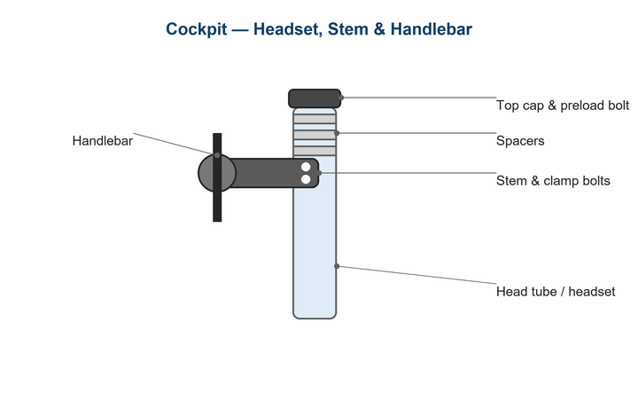
Figure 1. The headset bearings sit in the head tube; the top cap sets preload.

Likely Causes
- Headset preload has loosened, leaving bearing play.
- Over-tightened preload binding the bearings.
- Worn, dry, or pitted headset bearings.
- Loose stem clamp bolts mimicking headset play.
- A loose or worn fork/steerer interface.
Safety first
- The headset connects the steering to the frame — don't ride with play or binding.
- Set the top cap to preload only; the stem bolts (not the top cap) clamp the steerer.
- Re-check after the first short ride as the assembly settles.

Customer Fix — Step by Step
Suitable for home repair with basic tools. Work through the steps in order.
- Hold the front brake and rock the bike forward and back. A knock or movement at the head tube indicates play.
- Lift the front wheel and turn the bars — if steering is rough or notchy, the bearings need service, not just preload.
- Loosen the two stem clamp bolts on the steerer.
- Gently snug the top-cap bolt until the play just disappears (usually 1–2 N·m) — do not over-tighten.
- Align the stem with the front wheel and re-tighten the stem clamp bolts to spec, alternating evenly.
- Re-check: no play when rocking the bike, and the bars should turn freely and smoothly.

Technician Reference
Additional checks and adjustments for service technicians and advanced users.
- If preload won't remove play, check there is a 2–4 mm gap between the top of the steerer and the top of the stem/spacers — add a spacer or trim as needed so the cap can preload.
- Disassemble, clean, and inspect the bearings; replace pitted or rusty cartridges/balls.
- Grease the bearing seats and races; check the crown race and compression ring for wear.
- Confirm the fork steerer is not cracked and is the correct length.
- Reassemble, set preload, then torque the stem to spec.

Torque & Specifications
Fastener / setting | Specification
Top-cap preload bolt | Snug only, ~1 – 2 N·m
Stem steerer clamp bolts | 5 – 6 N·m
Steerer-to-stem top gap | 2 – 4 mm
Stem bar clamp bolts | 5 – 6 N·m
Bearing service | Clean & grease yearly

Figure 2. Preload with the top cap first, then clamp the stem to the steerer.
Pro tips
- Order of operations matters: preload with the cap, then tighten the stem bolts.
- A faint knock only under braking is almost always headset play.

When to Visit a Service Center
- Bearings are pitted, rusted, or notchy and need replacement.
- There is no gap above the steerer to allow preload.
- You suspect a cracked steerer or head tube.
- Play remains after correct preload and stem torque.
This guide is provided for reference. Torque values are typical starting points — always follow the specific component manufacturer's instructions. © Adventure Works.

